**IT20035808 (B. A. I. Fernando) - Bill Management**

**Service Design**

API of the Service

The Bill Management service focuses on the monthly bills of its customers; there are four main components. The create bill function allows the user to enter bill details such as the user, unit cost, units used and date. The system calculates the bill cost and creates a bill. The bill info is connected to the specific user through their userID which is implemented as a foreign key in the table.If bills have payments they will be updated as settled bills. The respective users can view the bills and also delete unwanted ones.

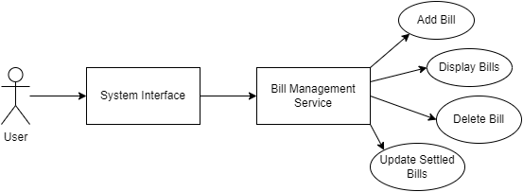

Use Case Diagram

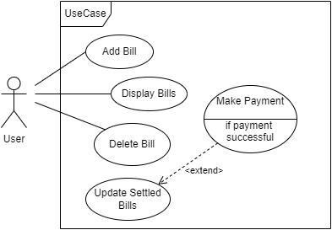

The use case diagram shows the four major

functionalities in the bill management service

and its connections to other services.

Class Diagram

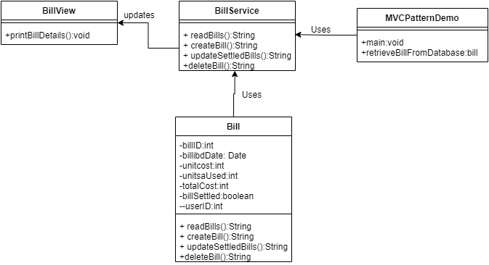

Describes the classes in the service.

Activity Diagram

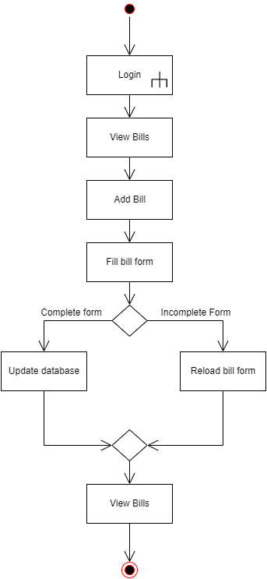

The activity diagrams describes functions related to creating bills functionality

Sequence Diagram

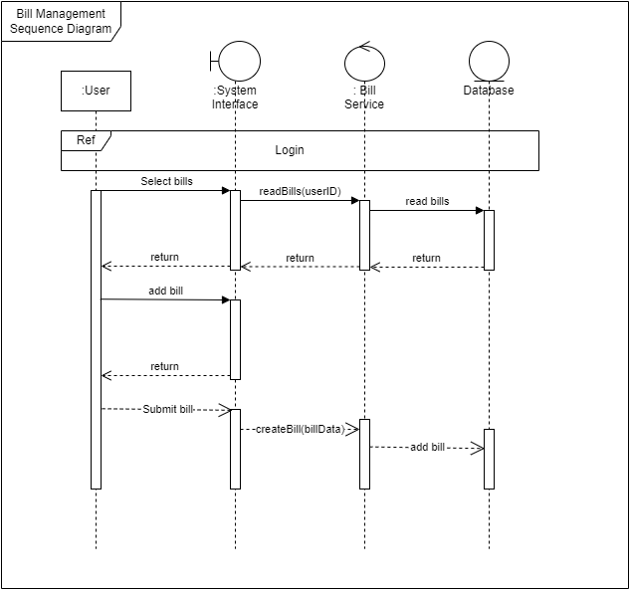

The sequence diagram contains the entity types and sequence of messages involved during the create or add bill functionality.

Flow Chart

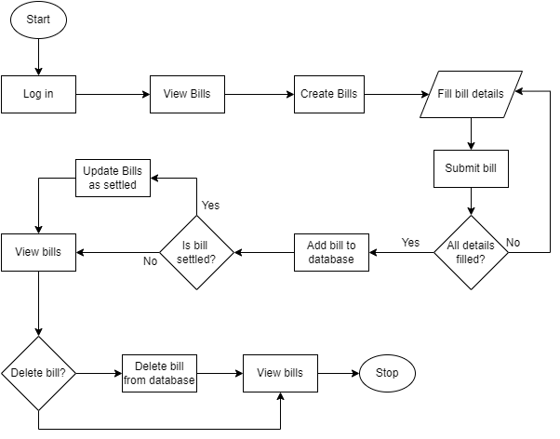

The flow chart shows a basic flow of events with regards to all four functions of the Bill Management service.

**Database table design**

ER diagram

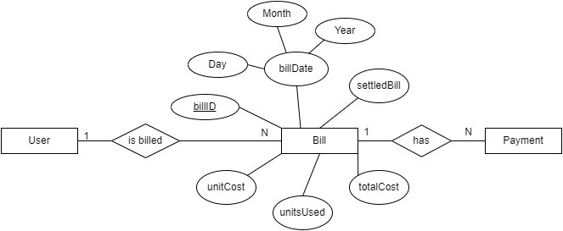

**Tools Used**

|  | **Tool Used** | **Justification** |
| --- | --- | --- |
| Back end | JAR-XS, Jersey, Java | Easy configuration and platform learned through lab knowledge |
| Database | PhpMyAdmin | Easy to configure and Integrate. |
| Server | Tomcat server by Xampp | Most widely used and documented server. |
| IDE | Eclipse | Familiarity and documentation |
| Testing Tool | Postman | Widely used with existing experience |

**Testing**

Service url**: http://localhost:8060/ElectroGrid/BillService/Bills**

| Test | Test Input | Expected output | Actual output |
| --- | --- | --- | --- |
| Read bills  functionality | <userData>  <userID>3</userID>  </userData> | HTML table of bill data | <table border='1'>  <tr>  <th>Bill ID</th>  <th>Billing Date</th>  <th>Unit Cost</th>  <th>Units Used</th>  <th>Service Charge</th>  <th>Total Cost</th>  <th>Bill Settled</th>  <th>User ID</th>  <th>Update</th>  <th>Remove</th>  </tr>  <tr>  <td>11</td>  <td>2022-02-01</td>  <td>10</td>  <td>16</td>  <td>1000</td>  <td>1160</td>  <td>false</td>  <td>3</td>  <td><input name='btnUpdate' type='button' value='Update' class='btn btn-secondary'></td>  <td>  <form method='post' action='items.jsp'>  <input name='btnRemove' type='submit' value='Remove' class='btn btn-danger'><input name='itemID' type='hidden' value='11'></form>  </td>  </tr>  </table> |
| Create bill functionality | billingDate:2022-03-01  unitCost:10  unitsUsed:13  serviceCharge:1000  billSettled:false  userID:1  Input type: application form url-encoded | Inserted Successfully | Inserted successfully |
| Update for settled bills functionality | {  "billID":"11",  "billSettled":false  } | Updated successfully | Updated successfully |
| Delete functionality | <billData>  <billID>13</billID>  </billData> | Deleted successfully | Deleted successfully |